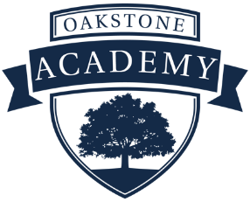
Licensed Middle School Social Studies Teacher
2025-26 School Year
Oakstone Academy School
900 Club Drive
Westerville, OH 43081
614-865-0400

CCDE/Oakstone Academy School is seeking a licensed Middle School Social Studies Teacher with the Ohio Department of Education for the 2025-26 school year. This is a full-time teaching position offering a 185-day teaching contract. This position also offers a competitive salary, comprehensive benefits, a retirement package, and accrued sick and personal leave time.

The Children’s Center for Developmental Enrichment (CCDE)/Oakstone Academy School is a private, chartered school in central Ohio serving approximately 625 typically developing and special-needs students from Pre-Kindergarten through High School. It is located in Westerville, Ohio, northeast of Columbus. Our special-needs students primarily have Autism Spectrum Disorder.

Certification/License in any of the following:
- 4-9 Middle Childhood Social Studies

Job Description and Requirements:
- Teach Social Studies in grades 6-7 to assist students with learning history, geography, politics, economics, and culture.
- Working cooperatively and collaboratively in a team environment and comfortable delegating tasks to team members, such as teaching aids and other content, to lead teachers
- Differentiate Lesson Plans and Academic Instruction for students with diverse learning abilities
- Integrate current events to facilitate healthy debate and engage in classroom discussion.
- Work closely with general education colleagues, Intervention Specialists, and Therapy Teams.
- Be comfortable using Google Docs, other educational technology, including Email, Microsoft Word, and curriculum-based software.
- Develop lesson plans and instructional materials and translate lesson plans into learning experiences to best utilize the available time for social studies instruction.
- Communicate consistently with families concerning academic, social, and behavioral goals.
- Administer formative and summative progress evaluations to demonstrate the effectiveness of instructional practices.
- Perform other duties as assigned
Qualifications
- Required License: Social Studies Middle Childhood (4-9)
- Ability to work independently and in a team environment
- Excellent oral and written communication and human relations skills
- Ability to build relationships with students, parents, colleagues, and outside organizations
- Ability to meet all deadlines and prioritize projects

Interested candidates should contact;

Wes Kremer
Human Resources Director
Oakstone Academy School
WKremer@ccde.org

CCDE/Oakstone Academy School is an equal-opportunity employer.

