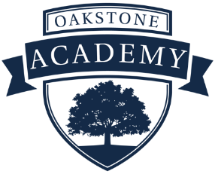
Licensed K-12 Intervention Specialist Teaching Opportunity
2022-23 School Year
Oakstone Academy School
900 Club Drive
Westerville, OH 43081
614-865-0400

CCDE/Oakstone Academy School is currently seeking a licensed K - 12 Intervention Specialist with the state of Ohio for the 2022-23 school year. This is a full-time teaching position offering a 185-day teaching contract. This position also offers a competitive salary, comprehensive benefits, and retirement packages, along with accrued sick and personal time.
The Children’s Center for Developmental Enrichment (CCDE)/Oakstone Academy School is a private, chartered school with the state of Ohio currently serving typically developing and special-needs students Pre-Kindergarten through High School located in Westerville, Ohio, northeast of Columbus. Our special-needs students primarily have Autism Spectrum Disorder.

Certification/License:
- Intervention Specialist Mild/Moderate (K-12)
- Intervention Specialist Moderate/Intensive (K-12)

Job Description and Requirements:
- Working cooperatively and collaboratively in a team environment and comfortable delegating tasks to team members such as teaching aids and other content to lead teachers
- Differentiate Lesson Plans and Academic Instruction for students with diverse learning abilities
- Work closely with Speech and Occupational Therapies to meet IEP goals
- Write and implement behavior improvement plans
- Create and write IEP goals and objectives and facilitate IEP meetings
- Communicate consistently with families concerning academic, social, and behavioral goals
- Administer formative and summative progress evaluations to demonstrate the effectiveness of instructional practices.
- Perform other duties as assigned

Qualifications
- Required License: Intervention Specialist Mild/Moderate (K-12) or Intervention Specialist Moderate/Intensive with the state of Ohio
- Ability to work independently and in a team environment
- Excellent oral and written communication and human relations skills
- Ability to build relationships with students, parents, colleagues, and outside organizations
- Ability to meet all deadlines and prioritize projects

Interested candidates should contact;

Wes Kremer
Human Resources Director
Oakstone Academy School
WKremer@ccde.org

CCDE/Oakstone Academy School is an equal opportunity employer.

